ADARSH MATHEW  Kalathil house  Sanathanam ward,  Alappuzha -688 001,  Kerala  India  Phone No - +918547332334  Email-a35488@gmail.com | 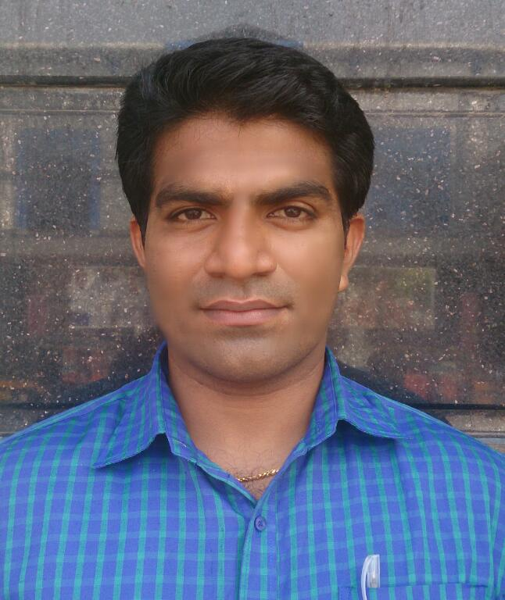
OBJECTIVE

To fulfill a position at a company where I can grow individually and professionally. A company where I can apply the knowledge I have and increase it as well. Knowing beforehand that I will have to reattribute that knowledge with hard work.

Work Experience-Total 4 Years-5 Months
- Relationship Associate in Axis Bank for Max life Insurance
Alappuzha-cherthala-changanaserry
2014 May to Still
*Dedicated R.A for Axis Bank Branches for doing Life Insurance Business.
* Achieved 110% of My target till date.
- Junior Business Analyst/project coordinator in Mindsoft Global, Phase-1, leela infopark,kochi-Dubai

2012 November to 2014 May
*Online and field Marketing, Software presentation and Company mediator in
price negotiations
* Got offer to work with mindsoft in Dubai
- International Client Relation Officer in Royal Palm Exports Alappuzha
2010 March to 2012 April
*Worked as Business coordinator with International Online and offline marketing.
Educational Qualifications
Currently doing Final semester MBA in Marketing from Sikkim Manipal University as distance education. I am a commerce graduate. I had also done .NET from NIIT and PGDCA.I scored 70% on my 12th and 75% on my 10th grade.
Personal Information:

Name : ADARSH MATHEW
Age : 26
Date of Birth : 29th NOVEMBER 1988
Marital Status : Single
Languages Known : English, Hindi, Malayalam and Tamil

Skills

*Client relations
*Documentation
*Team coordinator
*Excellent Communication skill
*Negotiations skill
*Solution making
*Quick learner

Reference

Mr.Ratheesh Kumar
Cluster Manager-Trivandrum Cluster
Axis Bank Relation
8589055038

Mr.Anuraj R
Former-Deputy Cluster Manager-Trivandrum Cluster
Axis Bank Relation
9544611888

Mr.Bijoy
Managing Director- Mindsoft Global Kochi
+919747064405

Mr.C.J.Mathew
MD,Royal Palm Exports Alappuzha
+919847450611

